Community Engagement Project
Report on
“Digital Lost & Found Portal For Public Space ”
Submitted by:
Mr Deepak Rai
In the partial fulfilment for the award of the degree
of
Bachelor of Science
in
Computer Science
Under the guidance of
Mr. Jaimishkumar Prajapati


Smt. Devkiba Mohansinhji Chauhan
College Of Commerce & Science, Silvassa
(Affiliated to University of Mumbai)
Academic Year: 2026–27

Smt. Devkiba Mohansinhji Chauhan
College Of Commerce & Science, Silvassa
(Affiliated to University of Mumbai)
Silvassa – UT OF DD & DNH – 396230
Department Of Computer Science & Information Technology

Certificate
This is to certify that Mr. Deepak Rai of T.Y.B.Sc. CS (Semester - V) class has satisfactorily completed the Project “Digital Lost & Found Portal For Public Space”, to be submitted in the partial fulfilment for the award of Bachelor of Science in Computer Science during the academic year 2026–2027.

Date of Submission:
Project Guide | Signature of Examiner
College Seal | Coordinator

Guide Interaction Diary Form
I, the undersigned Mr. Deepak Rai , Seat No. 510516069 , studying in the Third Year of
B.Sc. Computer Science Full-Time Course, is doing my project work under the guidance of Mr. Jaimishkumar Prajapati .
I hereby state that I have met my Internal Guide on the following dates mentioned below for Project Guidance.

Sr. No | Date | Signature of the Internal Guide

Student Signature: Internal Guide Signature:

Declaration
I, Deepak Rai, hereby declare that the project entitled “Digital Lost & Found Portal For Public Space” submitted in partial fulfilment for the award of Bachelor of Science in Computer Science during the academic year 2026–2027 is my original work carried out under the guidance of Mr. Jaimishkumar Prajapati, and the project has not formed the basis for the award of any degree, associateship, fellowship, or any other similar titles.

Place:
Date:

Signature of Student:
Seat No:

Acknowledgement
It gives me great pleasure to express my sincere gratitude to everyone who has supported and guided me throughout the completion of this Community Engagement Project.
First and foremost, I would like to express my heartfelt gratitude to my Project Guide, Mr. Jaimishkumar Prajapati, for her valuable guidance, continuous encouragement, and constructive feedback throughout the project.
I am also thankful to our honourable Principal, Dr. Seema Pillai and the faculty members of the Computer Science Department for their cooperation and support, which helped me complete this project successfully.
I extend my sincere thanks to the Management and the Principal of Smt. Devkiba Mohansinhji Chauhan College of Commerce and Science for providing me with the opportunity to undertake this project.
I would also like to thank all the students, teachers and campus staff whose everyday experiences of losing and finding belongings inspired the idea of ReClaim and helped shape its features.
Finally, I express my heartfelt gratitude to my family and friends for their constant support, motivation, and encouragement throughout this academic journey.

Deepak Rai

Table Of Contents
Chapter 1: Introduction 1
1.1. Purpose of the Project 1
1.2. Background Information 2
1.3. Scope of the Report 2
Chapter 2: Literature Review 3
Chapter 3: Methodology 4
3.1. Problem Identification and Requirement Analysis 4
3.2. Technology Stack 5
3.3. System Architecture and Data Flow 5
3.4. Development, Deployment and Version Control 8
Chapter 4: Implementation, Observations and Analysis 9
4.1. Module Overview 9
4.3. Module 1: Smart Item Reporting 10
4.4. Module 2: Multi-Parameter Algorithmic Match Engine 11
4.5. Module 3: Claim Verification and Custody Protocol 11
4.6. Module 4: Interactive Campus Geolocation Map 12
4.7. Module 5: Administration and User Management 13
4.8. Module 6: Native Android Mobile Application 14
4.9. Security and Governance Measures 14
4.10. Project Deliverables 14
4.11. Survey Findings and Analysis 14
Conclusion and Recommendations 19
References 20

Chapter 1: Introduction

Purpose of the Project
The main purpose of FindIt – Digital Lost & Found Portal is to provide a simple, user-friendly, and digital platform where people can easily report lost and found items in public places. The system helps users share information about missing or found belongings such as mobile phones, bags, wallets, documents, keys, and other personal items.

Through this portal, users can submit reports by entering the item name, category, location, date, description, and uploading an image of the item. Users can also browse reported items, search for specific items, apply filters, and view their submitted reports. The system provides additional features such as editing reports, deleting reports, and marking items as resolved.

The main objective of this project is to reduce the difficulties faced by people while searching for lost belongings. It makes the lost-and-found process more organized, convenient, and time-saving. Overall, FindIt aims to create awareness and provide an easy digital solution for managing lost and found items.

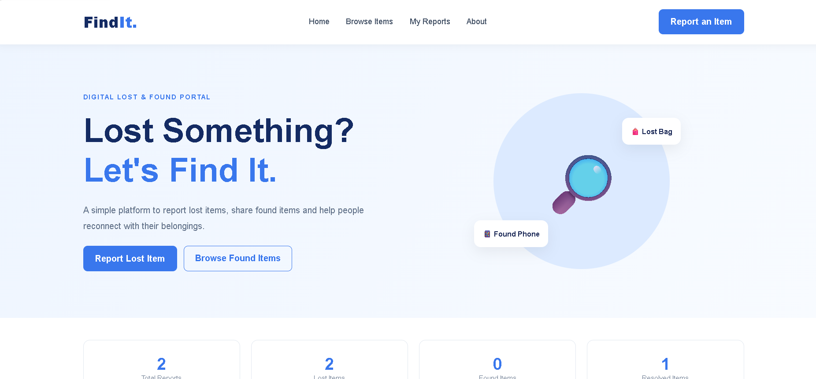

Fig. 1.1. Dashboard

1.2. Background Information

Losing personal belongings in public places is a common problem faced by many people. Items such as mobile phones, wallets, bags, keys, identity cards, and important documents are often lost in places like colleges, parks, bus stations, shopping malls, and other public areas. Similarly, people sometimes find items that belong to someone else but do not know how to contact the actual owner.

Traditionally, lost and found items are managed through manual methods such as notice boards, verbal communication, security offices, or lost-and-found counters. These methods are often time-consuming and may not provide proper information about missing or found items. As a result, many people face difficulties in finding their belongings.

With the growth of digital technology and internet usage, online platforms have become an effective way to share and manage information. A digital lost-and-found system can make this process easier by allowing users to report lost or found items, upload images, search for items, and view available reports.

FindIt – Digital Lost & Found Portal is developed to provide a simple and organized digital solution for this problem. It uses HTML, CSS, and JavaScript to create a user-friendly interface. The project also uses browser LocalStorage to save report information for demonstration purposes. It aims to make the process of reporting and searching for lost and found items easier, faster, and more convenient.

Scope of the Report
This report explains the development and working of FindIt – Digital Lost & Found Portal, a web-based frontend project designed to help people report and search for lost and found items in public places.
The scope of this report includes the following points:
1. Project Overview: Provides an introduction to the FindIt portal, its purpose, background, and objectives.
2. Technology Used: Explains the use of HTML, CSS, and JavaScript for developing the website.
3. System Design: Describes the structure, layout, and main components of the portal.
4. Report Management: Explains how users can submit lost or found item reports with details and images.
5. Search and Filter: Describes how users can search for items and filter reports based on their type.
6. My Reports: Explains how users can view, edit, delete, and mark their submitted reports as resolved.
7. Testing: Covers the testing process to check whether the website features work correctly.
8. Limitations and Future Scope: Discusses the current limitations of the frontend prototype and possible improvements for future development.
The report covers the design, implementation, features, and testing of the project. It focuses on the frontend functionality and browser LocalStorage used to store demonstration data. Backend services, online database connectivity, and real user authentication are not included in the current version.

Chapter 2: Literature Review

A literature review helps to understand the existing methods, technologies, and systems related to the development of a Digital Lost & Found Portal. It provides information about how lost and found items are managed and how digital technology can improve this process.

Traditionally, lost and found items are managed manually through notice boards, security offices, help desks, and public announcements. These methods are simple but have limitations such as slow communication, limited information sharing, and difficulty in tracking lost items.

With the development of web technologies, online lost-and-found platforms have become a useful way to share information about missing and found belongings. These platforms allow users to submit item details, upload photographs, search for items, and view available reports. This makes the process more organized and convenient.

The development of FindIt – Digital Lost & Found Portal is based on the use of modern web technologies:

1. HTML: Used to create the structure and content of the website.

2. CSS: Used to design the website and make its interface attractive and responsive.

3. JavaScript: Used to add interactive features such as searching, filtering, editing, deleting, and updating reports.

4. LocalStorage: Used to store item reports in the user's browser for demonstration purposes.

From the study of existing methods and web technologies, it is understood that a digital platform can make the lost-and-found process easier and more accessible. Therefore, FindIt is developed as a frontend-based solution to provide an organized way to report, search, and manage lost and found items.

Chapter 3: Methodology

3.1. Problem Identification and Requirement Analysis
People often lose personal belongings like mobile phones, wallets, bags, and documents in public places. Traditional methods of finding lost items are time-consuming and difficult. FindIt provides a digital platform to report, search, and manage lost and found items easily.
Requirement Analysis:
The main requirements of the project are:
- Functional: Submit reports, upload images, search, filter, edit, delete, and resolve items.
- Software: Windows 10/11, VS Code, HTML, CSS, JavaScript, and Google Chrome.
- Hardware: Computer or laptop and smartphone for testing.
- Storage: Browser LocalStorage for saving report information.

3.2. Technology Stack
The FindIt – Digital Lost & Found Portal is developed using the following technologies:
1. HTML: Used to create the structure of the website.
2. CSS: Used for styling and responsive design.
3. JavaScript: Used to add interactive features like search, filter, edit, and delete.
4. LocalStorage: Used to store report data in the browser.
5. Visual Studio Code: Used for writing and editing code.
6. Live Server: Used to run and test the website locally.

3.3. System Architecture and Data Flow
FindIt follows a simple frontend-based architecture. HTML provides the website structure, CSS manages the design, and JavaScript handles user interactions. Browser LocalStorage stores the submitted item reports.
Data Flow:
1. User opens the FindIt website.
2. User submits a Lost or Found item report.
3. JavaScript validates and processes the entered information.
4. Report data is saved in browser LocalStorage.
5. Users can browse, search, and filter available reports.
6. Users can edit, delete, or mark their reports as resolved.
7. Updated information is displayed on the website.
The system works without a backend server or online database.
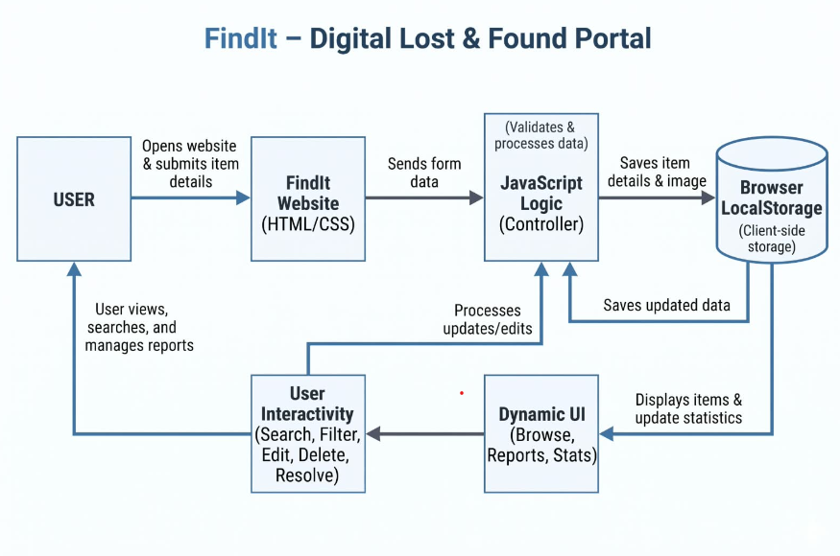
Fig. 3.3. Data Flow Chart

3.4. Development, Deployment and Version Control
1. Development
The FindIt project was developed using HTML, CSS, and JavaScript in Visual Studio Code. HTML was used to create the website structure, CSS for designing, and JavaScript for interactive features. LocalStorage was used to save item reports in the browser.
2. Deployment
The project was tested locally using the Live Server extension in VS Code. It can also be hosted online using platforms such as GitHub Pages or Netlify. Since it is a frontend-only project, no backend server is required.
3. Version Control
Git and GitHub can be used to manage project files and track changes. Version control helps maintain code history, update files, and restore previous versions when needed.
GitHub Repository: https://github.com/Deepakrai425/Digital-Lost-Found-Protal
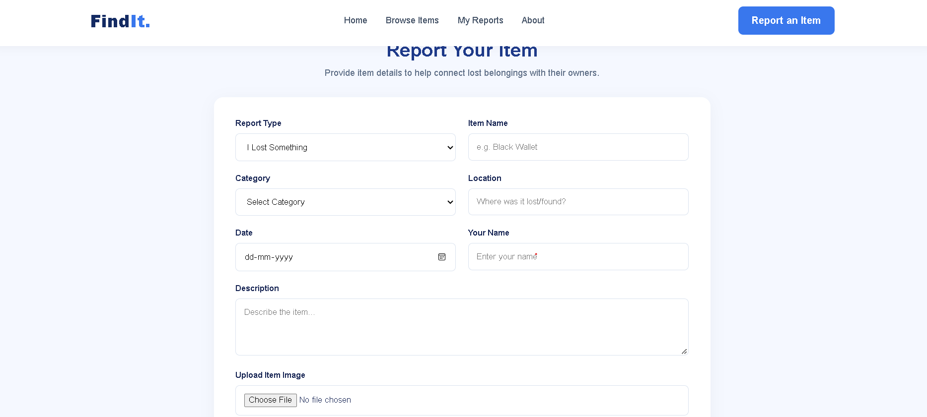
Fig.: 3.4.Dashboard of the Project website

Chapter 4: Implementation, Observations and Analysis

4.1. Module Overview
The FindIt project is divided into the following modules:
1. Home Module: Displays project information and navigation options.
2. Report Module: Allows users to submit Lost or Found item details with images.
3. Browse Items Module: Displays all reported lost and found items.
4. Search and Filter Module: Helps users find items by name, category, or type.
5. My Reports Module: Allows users to view and manage submitted reports.
6. Item Management Module: Provides options to edit, delete, and mark items as resolved.
7. Statistics Module: Displays the total number of lost, found, and resolved items.

4.2. Smart Item Reporting
The Smart Item Reporting module allows users to report lost or found items easily. Users can enter item name, category, location, date, reporter name, and description. They can also upload an item image. JavaScript validates the details and saves the report in Browser LocalStorage. This makes the reporting process simple and organized.

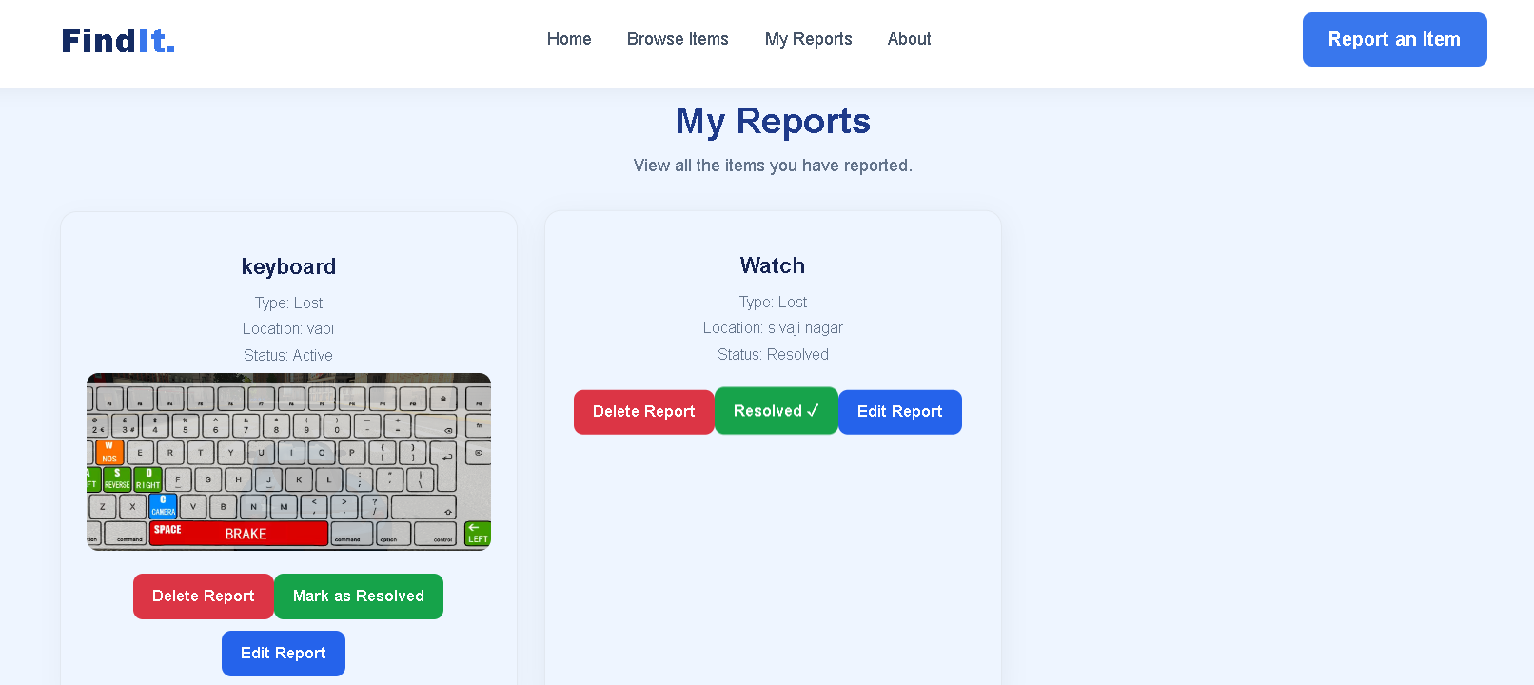
Fig : 4.2. Report Lost Item

4.3. Browse Items
The Browse Item module allows users to view all reported lost and found items on the website. It displays important information about each item, such as item name, category, description, image, location, and reporting date. Users can easily explore the available item listings and search for specific items. This module also helps users check the current status of reported items. It provides a simple and user-friendly interface to find lost belongings. Users can identify items reported by other people and get useful information about them. The module saves time by displaying all reported items in one place. Overall, the Browse Item module makes it easier for users to search, identify,and find their lost belongings.
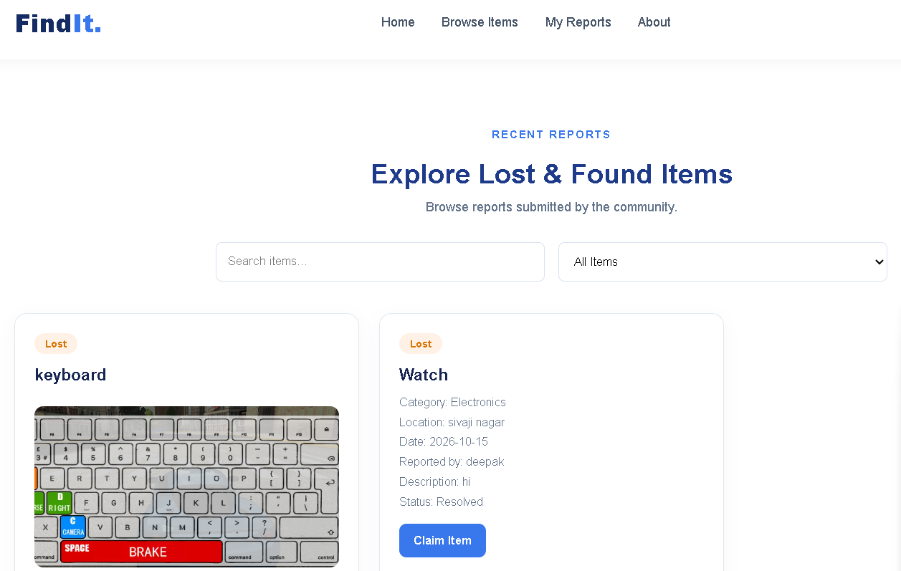
Fig : 4.3. Browse Item

4.4. Search And Filter
The Search and Filter module helps users easily find specific lost and found items from the available listings. Users can search for items by entering keywords such as item name or category. The filter option allows users to narrow down the results based on different categories, item types, locations, and status. It reduces the time required to find a particular item. Users can quickly view relevant results without browsing through all the reported items. This module provides a simple and user-friendly search experience. It helps users identify matching items more efficiently. The search and filter functionality improves the overall usability of the system and makes the process of finding lost and found items faster and easier.

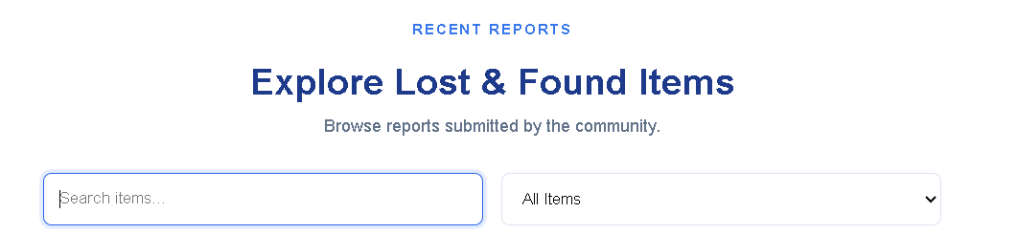

Fig.4:5 Search And Filter

4.5. My Reports
The My Report module allows users to view and manage the lost and found items reported by them. It displays all submitted reports along with important details such as item name, category, description, image, location, and reporting date. Users can easily check their previously submitted reports and track their current status. This module helps users keep a record of all reported items in one place. It also allows users to monitor updates related to their reports. Users can identify whether their reported item is still pending or has been found. The module provides an organized and user-friendly interface for managing reports. It reduces confusion and makes report tracking easier. Overall, the My Report module helps users manage their submissions and stay updated about their lost and found items.
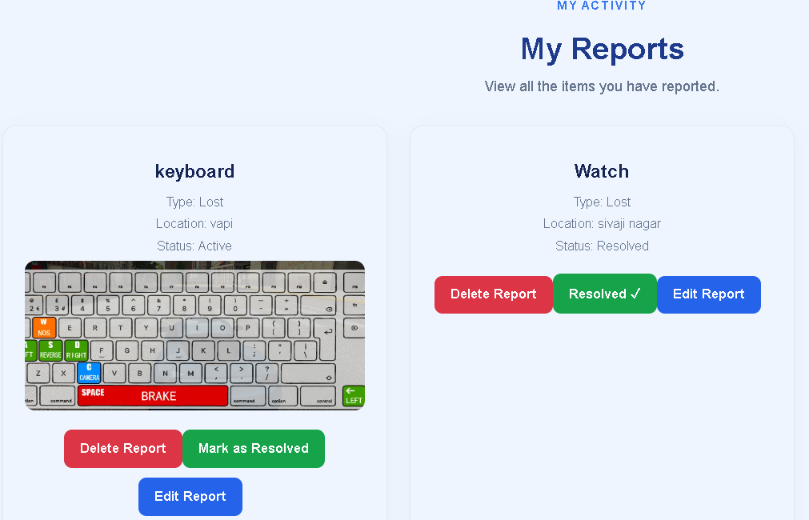
Fig.4.6: My Report

4.6. Edit , Delete and Resolve
The Edit, Delete and Resolve module allows users to manage their reported lost and found items easily. The Edit option helps users update item details such as item name, category, description, location, and other information if any changes are required. The Delete option allows users to remove reports that are no longer needed or were submitted by mistake. The Resolve option helps users mark a report as resolved when the lost item is found or the issue is successfully completed. These features help users maintain accurate and updated information in the system. They also reduce unnecessary reports and keep the item listings organized. Overall, this module provides better control over submitted reports and makes the system more useful and user-friendly.
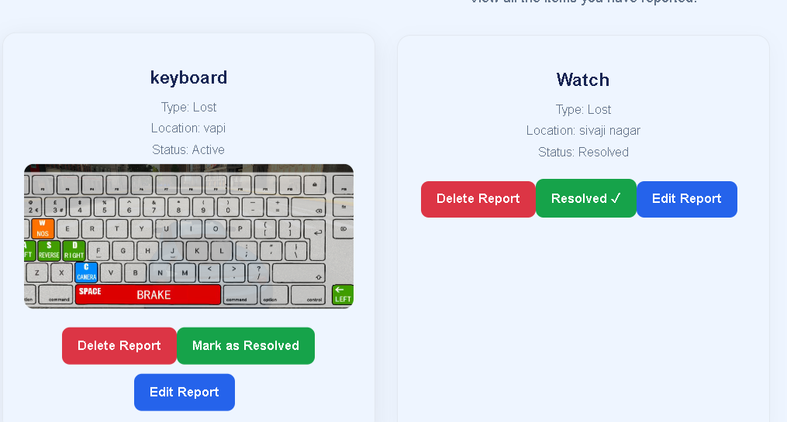
Fig.4.7: Edit, Delete and Resolve

4.7. Local Storage
Local Storage is used to store small amounts of data directly in the user's web browser. It helps the system save important information such as user preferences and temporary application data. The stored data remains available even after the browser is closed and reopened. It reduces the need to repeatedly enter the same information. Local Storage uses key-value pairs to save and retrieve data easily. JavaScript is used to access and manage the stored information. It improves the performance and user experience of the application. It also allows the application to remember certain details between browser sessions. Overall, Local Storage provides a simple way to store and manage data on the user's device.

Conclusion and Recommendations

Conclusion
The Community Engagement Project provides a simple and useful platform for reporting and managing lost and found items. It allows users to report lost or found items, browse available items, search and filter reports, and manage their own submissions. The system makes it easier for people to connect and share information about missing belongings. Features such as editing, deleting, and resolving reports improve the overall management process. The project provides a user-friendly interface and helps save time and effort. Overall, this project demonstrates how technology can be used to solve everyday problems and support the community.
Recommendations
The system can be improved by adding more advanced features in the future. Some recommendations are:
1. Add email or SMS notifications for report updates.
2. Implement an advanced search and filtering system.
3. Add image-based item recognition.
4. Improve user authentication and security.
5. Add a real-time chat feature between users.
6. Make the application mobile-friendly.
7. Add location-based search using maps.
8. Provide an admin panel for better report management.

References
The following resources were used for developing and understanding the Community Engagement Project:
1. W3Schools – HTML, CSS, and JavaScript tutorials. https://www.w3schools.com/
2. MDN Web Docs – Web development documentation. https://developer.mozilla.org/
3. PHP Official Documentation – PHP programming concepts and functions. https://www.php.net/docs.php
4. MySQL Documentation – Database creation and management.https://dev.mysql.com/doc/
5. Apache Friends (XAMPP) – Local server setup and configuration . https://www.apachefriends.org/
6. Visual Studio Code – Code editor and development environment .https://code.visualstudio.com/
7. Stack Overflow – Technical help and programming solutions. https://stackoverflow.com/
8. Google – General research and project-related information. https://www.google.com/

